November 14th 2025
Dear Parishioners,
Good evening/morning.

I am writing to you to update you on the situation in the parish following the move of Fr. Prem. We all understand how difficult it is for a parish to function normally without a permanent priest.

- I know that the Archbishop is endeavouring to appoint a new parish priest as soon as possible. As I’m sure you appreciate, there are less priests than years ago and this impacts on the whole Archdiocese where several large parishes have been similarly awaiting new appointments.
- During this interim period, I am trying to ensure that there are supply priests to cover the weekend Masses in the parish. Despite the relative high numbers of priests in our Deanery, with the presence of the Religious Orders, most of them already have Sunday and community commitments and, although willing, are not available. At the moment, all the usual weekend Masses are covered up to and including the Third Sunday of Advent and also the 11.00am Mass for Sunday December 21st, Christmas Day, December 28th and January 4th. I shall let you know as soon as possible about the other Masses for these dates.
- The Deanery will continue to cover emergency calls and provide for funerals and other pastoral needs that might arise.
- In the meantime, after a productive parish community meeting on Tuesday evening, there is a real commitment to ensure that the parish continues not merely to function but to flourish in its mission to build up the Kingdom of God. This needs the involvement of as many parishioners as possible and I hope you will all continue to support one another. Please contact me if you feel I can be of assistance.

With prayers and best wishes,

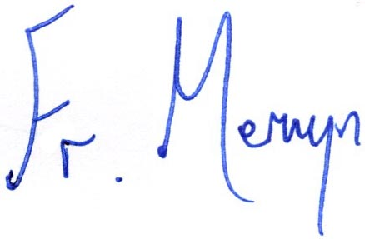

Fr. Mervyn Tower
Dean of Oxford North Deanery

